SQL Assignment - IT firm
Clients Table
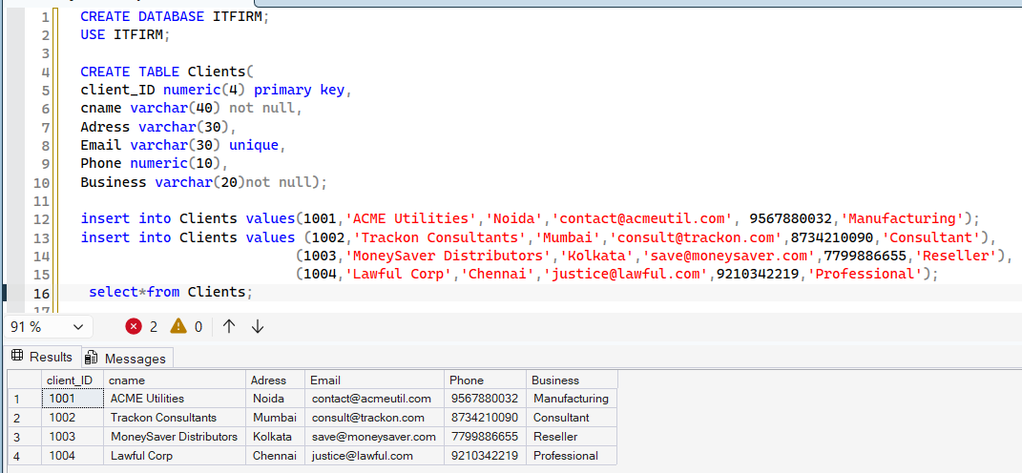

Employee Table
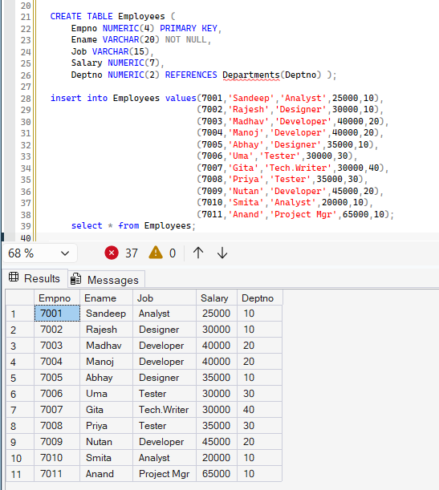
Departments Tables
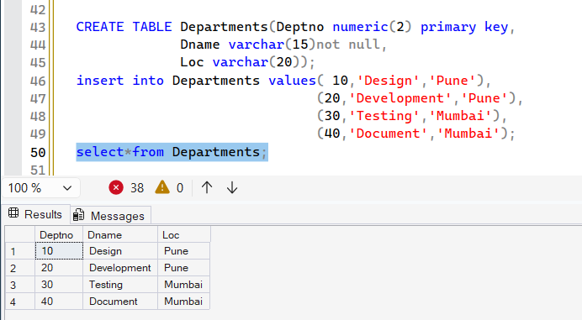

Project Table
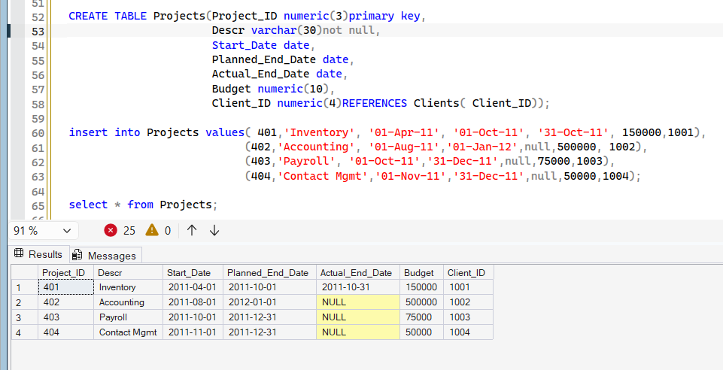

EmpProjectTask Table
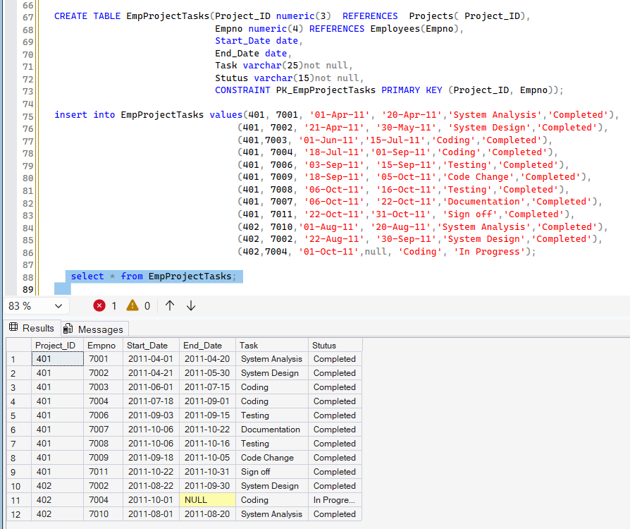

Question set 1
1.Display customer details with business ‘Consultant’
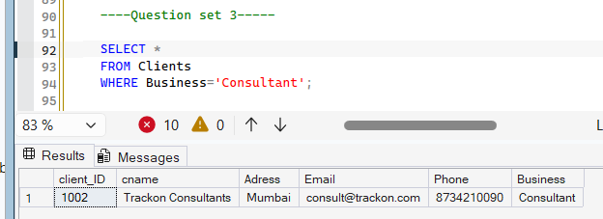
2.Display employee details who are not ‘Developers’
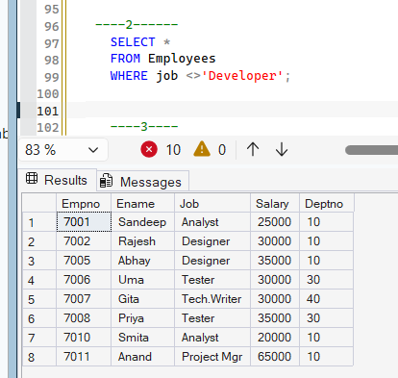
3.Display project details with budget>100000

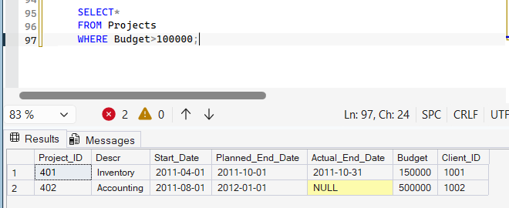
4.Display details of project that are already finished
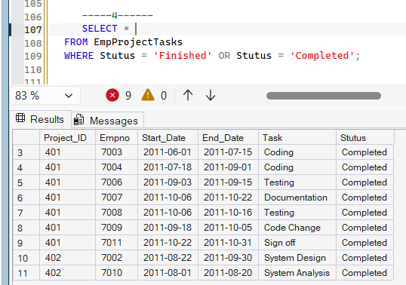
5. Display employee names beginning with ‘M’
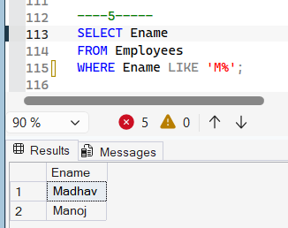
6. Display employee names ending with ‘a’
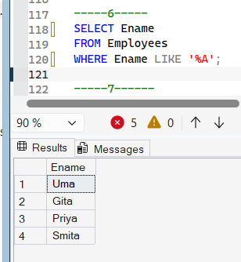

7. Display the number of months project ‘Inventory’ took for completion
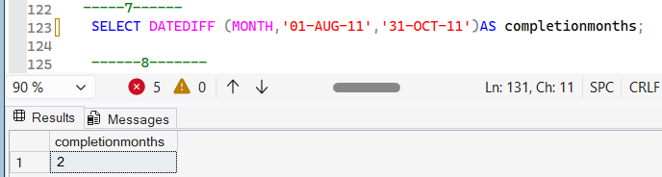
9.Display details of departments located in Pune
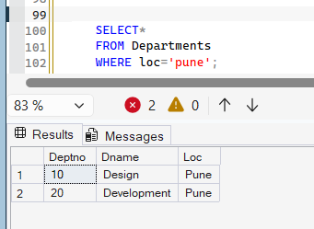
10.Display employee name and salary in descending order of salary
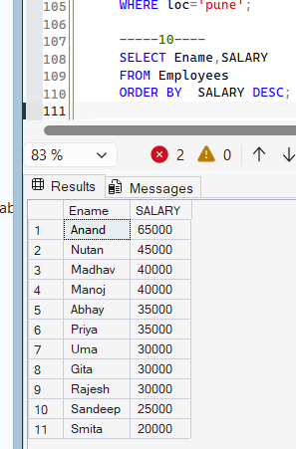

11.Display tasks in ascending order of end date
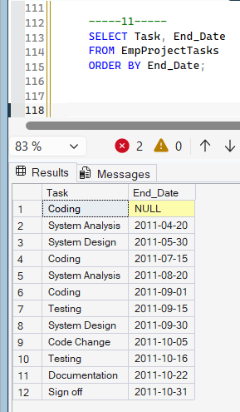
12.Display distinct jobs from Employees table
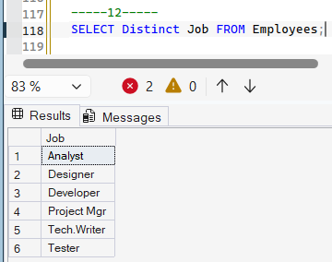

13. Display employee names in all uppercase
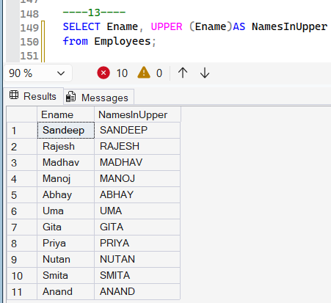

16. Display day of week (e.g. Friday) for each start date of projects
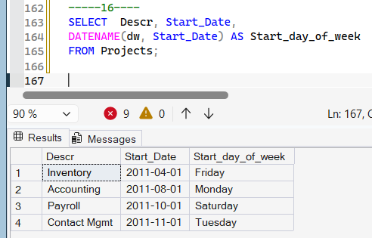
17. Display position number of ‘@’ symbol in each email id of clients
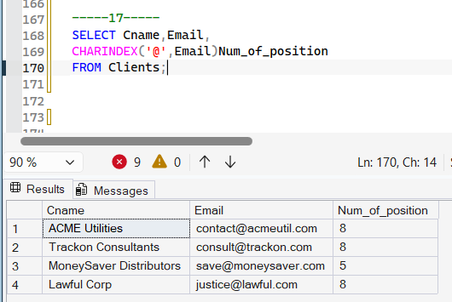

18. Display first 3 characters of each client name
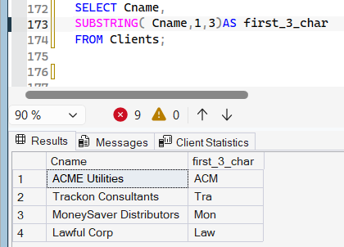
19. Display project budget values formatted as ‘$150,000’
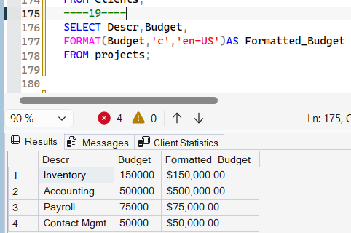
20. Display planned end date and review date as 3 months after planned end date for each project
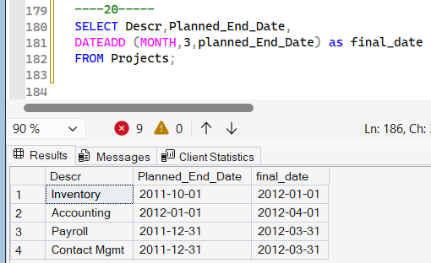

SET2
1. Display count of clients
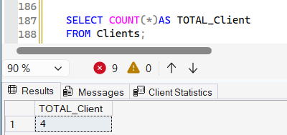
2. Display count of employees and sum of their salaries
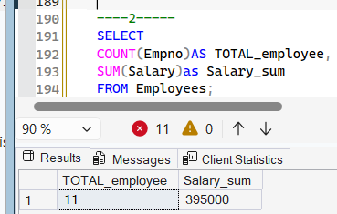
3. Display max salary per department

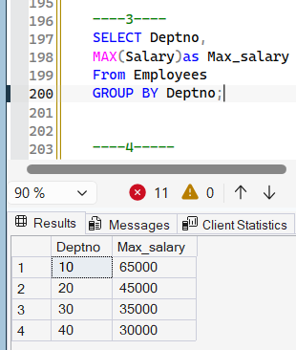

4. Display min salary per job
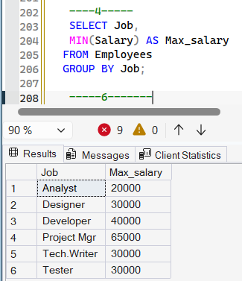
5. Display average salary
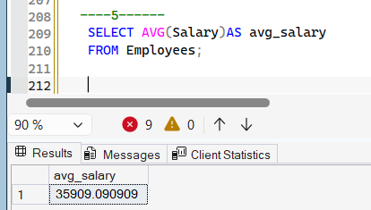
6. Display sum of budget
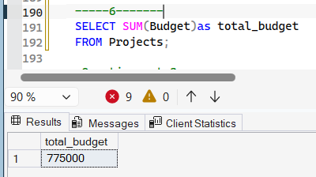

7. Display count of ‘Coding’ task
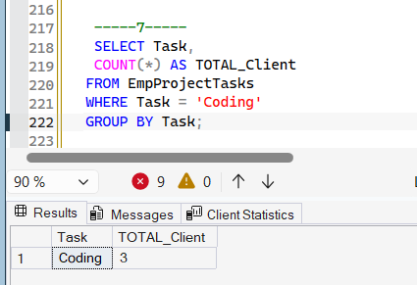

8. Display department wise count and sum of salary of employees
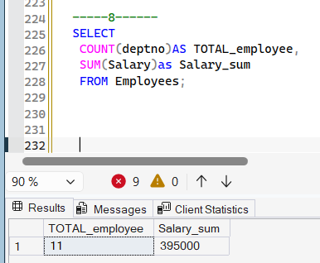

9. Display client names and their project desc, start date and budget
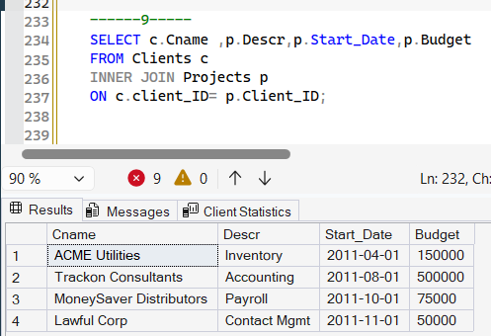

10. Display department name, employee name and job
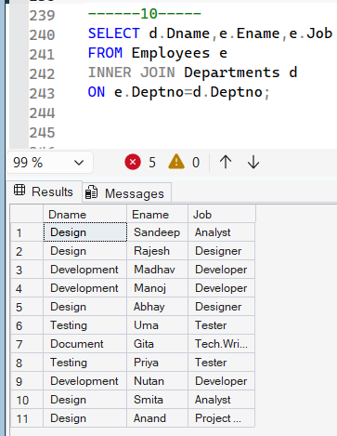
11. Display names of employees doing ‘System Analysis’ along with project name

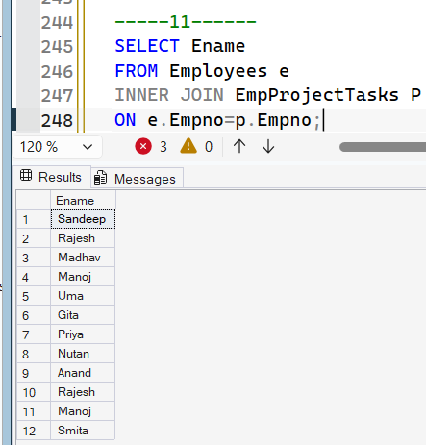
12. Display job wise count
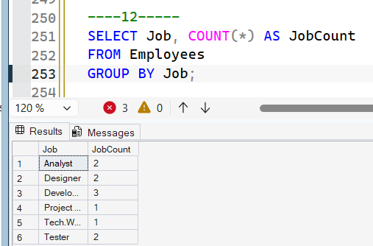
13. Display employee numbers not present in EmpProjectTasks table using necessary set operator
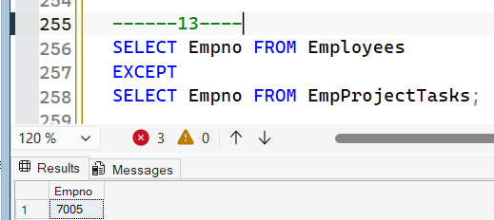
14. Display employee numbers present in both Employees and EmpProjectTasks table using necessary set operator
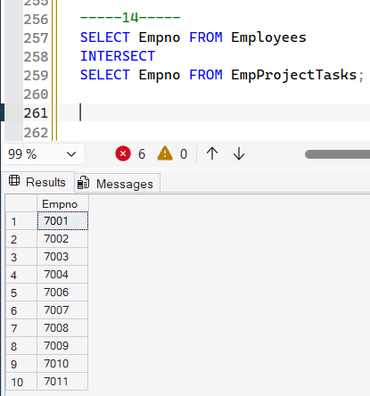
15. Display all employee numbers present in both Employees and EmpProjectTasks table using necessary set operator

Question set 3
1.Display the project name with highest budget

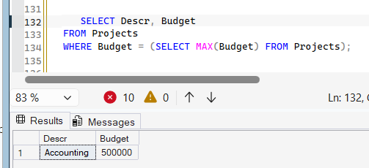
2. Display employee names who have same job as ‘Madhav’
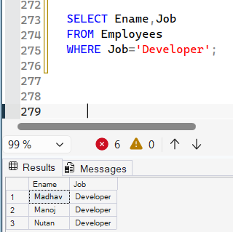
3. Display employee’s name and job who worked on ‘Code Change’ task of project 401
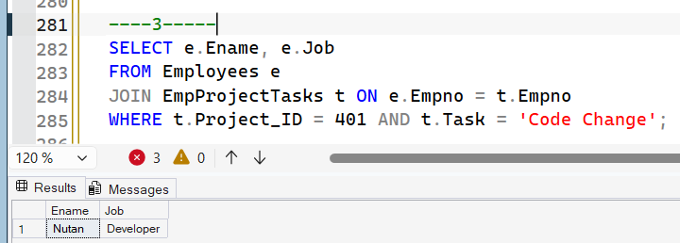
4. Display client name whose project’s ‘Coding’ task is ‘In Progress’
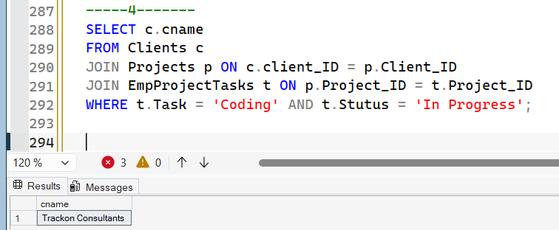
5. Display department number, names and salaries of employees who are earning max salary in their departments

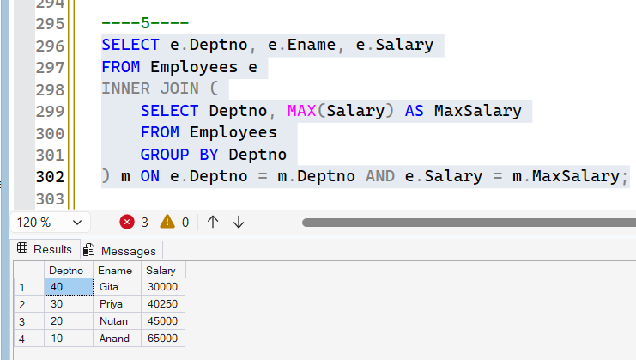
6. Display name of department with highest SUM of salary

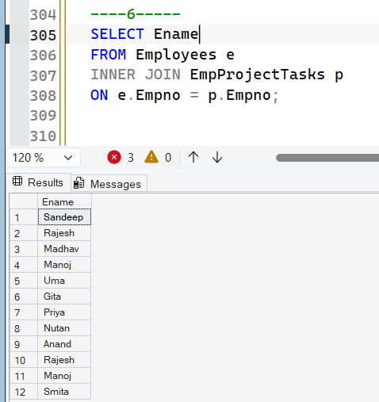
7. Create a table named ‘CLIENT_PROJECTS’ using CTAS method that includes CLIENT_ID, CNAME, ADDRESS,BUSINESS,DESCR,BUDGET columns from CLIENTS and PROJECTS tables
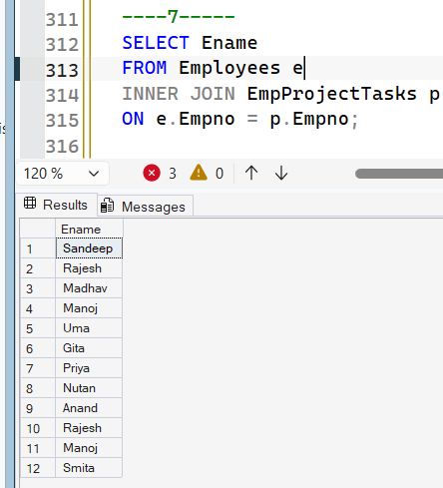

10. Create synonym EPT for table EmpProjectTasks
